3/24/2025

(Student C00270632) Qadeer Hussain

Lecture: Greg Doyle

Data Science & ML Log

# **Convolutional Neural Networks Log**

**19/03/2025**

* Reading up on CNN Neural Networks
* Experimented with existing CNN Notebook from GitHub.

**20/03/2025**

* After experimenting with the existing Handwritten digits recognition CNN notebook.
* Researched dataset to use.
* Dataset link: <https://www.kaggle.com/datasets/msambare/fer2013/data>
* The dataset was loaded and then explored.

**21/03/2025**

* Continue work on CNN.
* After exploring the dataset. Then processed the data.
* Built the model and trained it.
* Improved accuracy a bit by implementing data augmentation.
* Re-trained again and Tested the model and saved it for future use.

**24/03/2025**

* Made read me which includes the following:
  + Project Description
  + Data Source
  + Processing
  + Data Understanding and Visualisation
  + Algorithm
  + Online Sources
  + Tools and Tech Used

**Data Visualisation**

**Training & Validation loss:** The loss graph shows a steady decrease, indicating the model is learning effectively over each epoch.

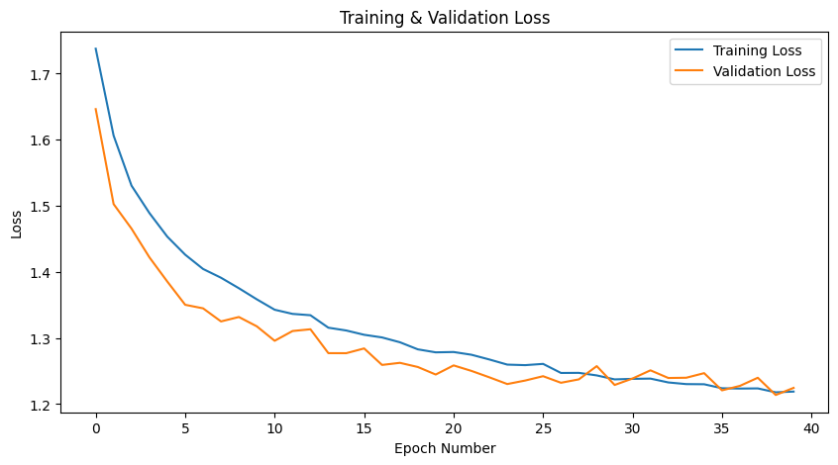

**Training & Validation Accuracy:** The accuracy graph shows consistent improvement, reaching around 52% accuracy by the final epoch**.**

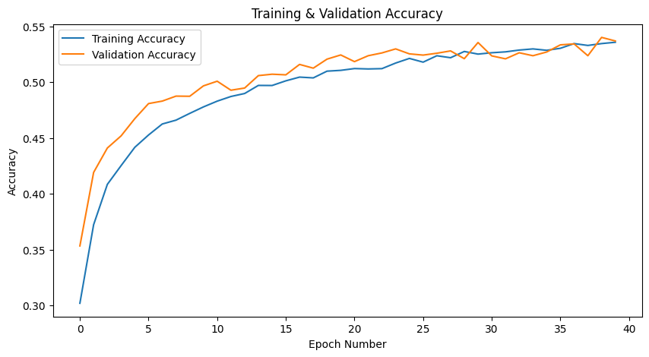

**Model in use:** The trained model was tested on unseen images, and its predictions were compared to actual labels for visual verification

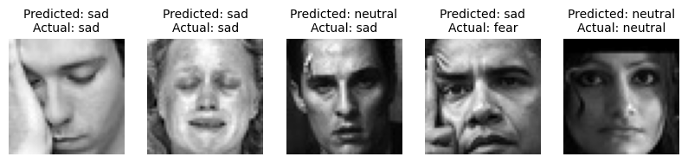

**For more information Git Link:** <https://github.com/Qadeer1813/Data-Science-and-Machine-Learning-CNN/>

# **Recurrent Neural Networks**

**19/03/2025**

* Reading up on the RNN Neural Networks.
* Experimented with existing RNN Notebook from GitHub.

**21/03/2025**

* After experimenting with the existing Shakespeare Text Generation (using RNN LSTM) notebook
* Researching dataset to use.
* Dataset link: <https://www.kaggle.com/datasets/johnhallman/complete-poetryfoundationorg-dataset>
* The dataset was loaded and then explored.
* Data processed,
* Built the model and train it.

**22/03/2025**

* **Issue:** While training my model TensorFlow defaulted to using my CPU instead of the GPU
* Attempted to fix this issue but could resolve it.
* Continued training the model on CPU, although it significantly increased training time.

**23/03/2025**

* After training model.
* Switched the dataset to improve output quality and model accuracy.
* The original dataset contained short and varied poem styles, which led to inconsistent results generation results.
* New Dataset link: <https://www.gutenberg.org/ebooks/12242>
* Trained model again.
* Tested model with different temperatures and saved the model.

**24/03/2025**

* Made read me which includes the following:
  + Project Description
  + Data Source
  + Processing
  + Data Understanding and Visualisation
  + Algorithm
  + Online Sources
  + Tools and Tech Used

**Data Visualisation**

**Training loss:** The loss graph shows a steady decrease, indicating the model is learning effectively over each epoch.

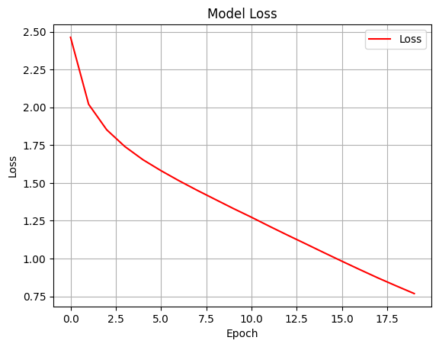

**Training Accuracy:** The accuracy graph shows consistent improvement, reaching around 76% accuracy by the final epoch.

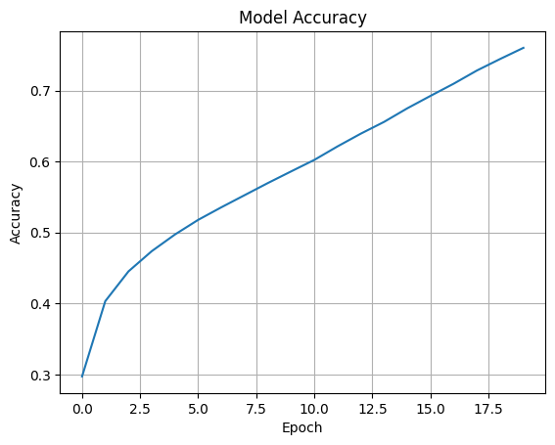

**Model in use:** The model generates text based on a seed input, with the output varying depending on the different temperatures values.

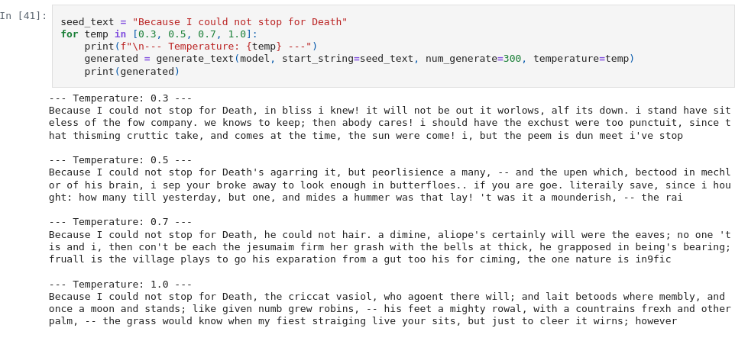

**For more information Git Link:** <https://github.com/Qadeer1813/Data-Science-and-Machine-Learning-RNN/>